Python Packages for   
Data Science

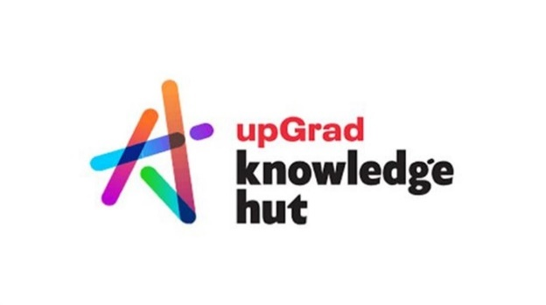

**Anish Mahapatra**

Contents

Introduction 4

Python Libraries – Overview 4

Why Use Python Libraries for Data Science 4

Ease of learning 4

Less Code 4

Prebuilt Libraries 4

Platform Independent 4

Massive Community Support 4

List of Python Libraries for Data Science – 2022 (Note: Include Features, image, pros & cons, and applications for each library) 4

Python Libraries for Math 4

NumPy 4

SciPy 4

Theano 4

Python Libraries for Data Exploration and Visualization 4

Pandas 4

Matplotlib 4

Plotly 4

Seaborn 5

Ggplot 5

Altair 5

Autoviz 5

Pydot 5

Python Libraries for Machine Learning 5

Keras 5

SciKit-Learn 5

PyTorch 5

Pycaret 5

TensorFlow 5

Requests 5

Python Libraries for Data Mining and Data Scrapping 5

Scrapy 5

BeautifulSoup 5

SQLAlchemy 5

Python Libraries For Natural Language Processing 5

NLTK 5

SpaCy 6

Gensim 6

Bonus Python Libraries! 6

OpenCV 6

Mahotas 6

SimpleITK 6

Pillow 6

Selenium s 6

PyTest 6

PyUnit 6

Conclusion 6

Frequently Asked Questions (FAQs) 7

Which library is most used in Python? 7

Which software is best for Python for data science? 7

Which Python library should I learn first? 7

Which Python library is used for machine learning? 7

How many libraries are in Python? 7

Author 7

# Introduction

# Python Libraries – Overview

## Why Use Python Libraries for Data Science

### Ease of learning

### Less Code

### Prebuilt Libraries

### Platform Independent

### Massive Community Support

# List of Python Libraries for Data Science – 2022 (Note: Include Features, image, pros & cons, and applications for each library)

## Python Libraries for Math

### NumPy

* Features
* Pros
* Cons
* Applications

### SciPy

* Features
* Pros
* Cons
* Applications

### Theano

* Features
* Pros
* Cons
* Applications

## Python Libraries for Data Exploration and Visualization

### Pandas

* Features
* Pros
* Cons
* Applications

### Matplotlib

* Features
* Pros
* Cons
* Applications

### Plotly

* Features
* Pros
* Cons
* Applications

### Seaborn

* Features
* Pros
* Cons
* Applications

### Ggplot

* Features
* Pros
* Cons
* Applications

### Altair

* Features
* Pros
* Cons
* Applications

### Autoviz

* Features
* Pros
* Cons
* Applications

### Pydot

* Features
* Pros
* Cons
* Applications

## Python Libraries for Machine Learning

### Keras

* Features
* Pros
* Cons
* Applications

### SciKit-Learn

* Features
* Pros
* Cons
* Applications

### PyTorch

* Features
* Pros
* Cons
* Applications

### Pycaret

* Features
* Pros
* Cons
* Applications

### TensorFlow

* Features
* Pros
* Cons
* Applications

### Requests

* Features
* Pros
* Cons
* Applications

## Python Libraries for Data Mining and Data Scrapping

### Scrapy

* Features
* Pros
* Cons
* Applications

### BeautifulSoup

* Features
* Pros
* Cons
* Applications

### SQLAlchemy

* Features
* Pros
* Cons
* Applications

## Python Libraries For Natural Language Processing

### NLTK

* Features
* Pros
* Cons
* Applications

### SpaCy

* Features
* Pros
* Cons
* Applications

### Gensim

* Features
* Pros
* Cons
* Applications

## Bonus Python Libraries!

### OpenCV

* Features
* Pros
* Cons
* Applications

### Mahotas

* Features
* Pros
* Cons
* Applications

### SimpleITK

* Features
* Pros
* Cons
* Applications

### Pillow

* Features
* Pros
* Cons
* Applications

### Selenium

* Features
* Pros
* Cons
* Applications

### PyTest

* Features
* Pros
* Cons
* Applications

### PyUnit

* Features
* Pros
* Cons
* Applications

# Conclusion

# Frequently Asked Questions (FAQs)

## Which library is most used in Python?

## Which software is best for Python for data science?

## Which Python library should I learn first?

## Which Python library is used for machine learning?

## How many libraries are in Python?

# Author

**Anish Mahapatra**   
*Senior Data Scientist*   
LinkedIn: https://www.linkedin.com/in/anishmahapatra (LinkedIn)   
Email: anishmahapatra01@gmail.com